 **BAHRIA UNIVERSITY (KARACHI CAMPUS)**

**ASSGINMENT # 1 - FALL 2021**

# Computer Architecture and Organization Lab (CEN-221)

Class: **BSE 3(B)**

Course Instructor: **Engr.Dr. Samar Yazdani Submission Deadline: 23rd December, 2021**

Lab Instructor: **Engr. Ramsha Mashood** Max Marks: **10**

Lab Instructor: **Muhammad Junaid Saleem Qadri** Enrollment No: **02-131202-057**

**Question 1:** Write a program in MIPS Assembly language to compare 2 numbers. If the numbers are same print the output as follows:

**The numbers are same**

And if the numbers are different print the output as follows:

**The numbers are different**

**Solution:**

.data

num1: .asciiz "Enter number 1 = "

num2: .asciiz "Enter number 2 = "

equal: .asciiz "The numbers are same"

different: .asciiz "The numbers are different"

.text

.globl main

main:

la $a0,num1

li $v0,4

syscall

li $v0,5

syscall

move $t0,$v0

syscall

b exit

match:

la $a0,equal

li $v0,4

syscall

b exit

exit:

li $v0,10

syscall

la $a0,num2

li $v0,4

syscall

li $v0,5

syscall

move $t1,$v0

beq $t0,$t1,match

la $a0,different

li $v0,4

**Output:**

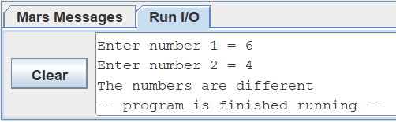

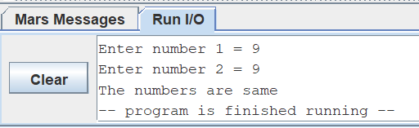

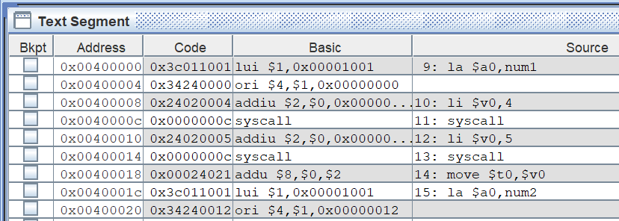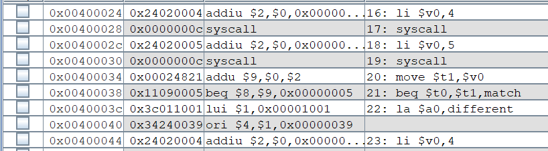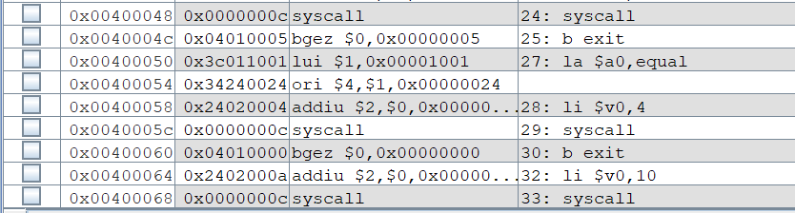

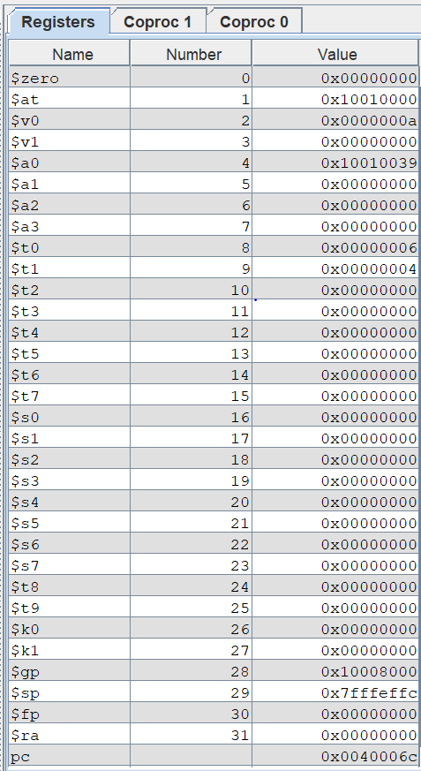

**Question 2: Write a program to print sum of even numbers up to a given range by the user.**

**Solution:**

.data

range: .asciiz " Enter the Range = "

output1: .asciiz " The Sum of all Even numbers ( "

output2: .asciiz " + "

output3: .asciiz " ) are = "

.text

.globl main

main:

li $s0,2

li $s1,0

la $a0,range

li $v0,4

syscall

li $v0,5

syscall

move $t0,$v0

la $a0,output1

li $v0,4

syscall

b compare

compare:

bge $t0,$s0,division

la $a0,output3

li $v0,4

syscall

move $a0,$s1

li $v0,1

syscall

li $v0,10

syscall

division:

div $t0,$s0

mfhi $t1

beqz $t1,even

subi $t0,$t0,1

beqz $s1,compare

b addsymbol

even:

move $a0,$t0

li $v0,1

syscall

addu $s1,$s1,$t0

subi $t0,$t0,1

b compare

addsymbol:

la $a0,output2

li $v0,4

syscall

b compare

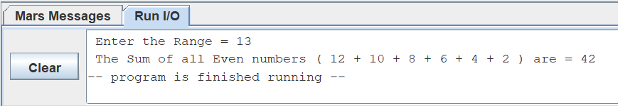**Output:**

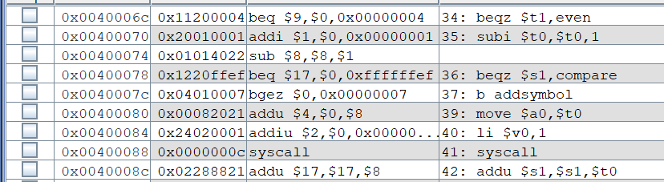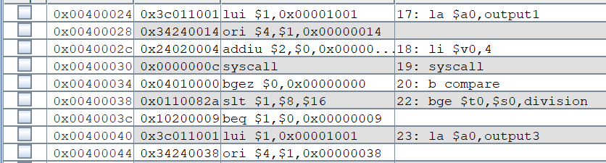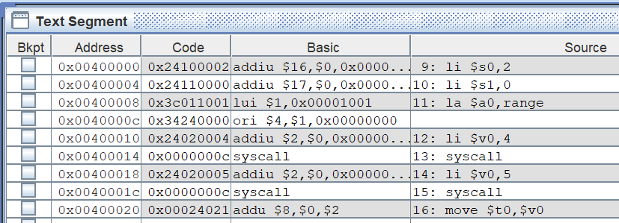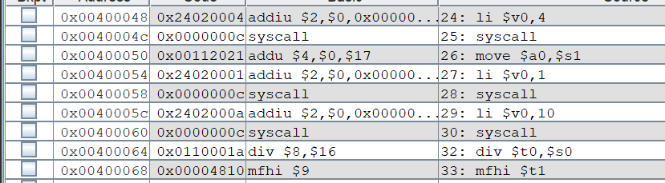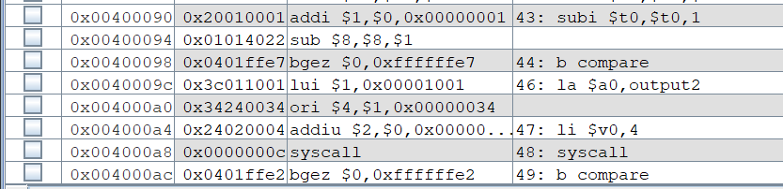

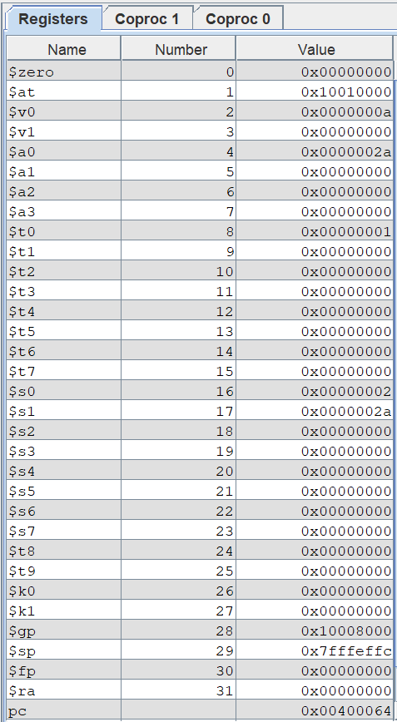

**Question 3:** **Write a program to get user’s input in double and print it.**

**Solution:**

.data

input: .asciiz "Enter the Decimal value = "

output: .asciiz "\nHere is your Double value = "

.text

.globl main

main:

la $a0,input

li $v0,4

syscall

li $v0,7

syscall

la $a0,output

li $v0,4

syscall

mov.d $f12,$f0

li $v0,3

syscall

li $v0,10

syscall

**Output:**

